**Output of the Arithematic Calculaor Programme**

**Addition**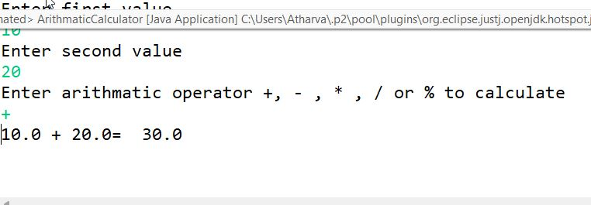

**Substraction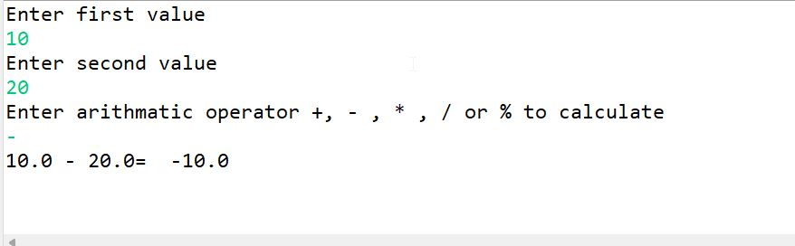Modulus**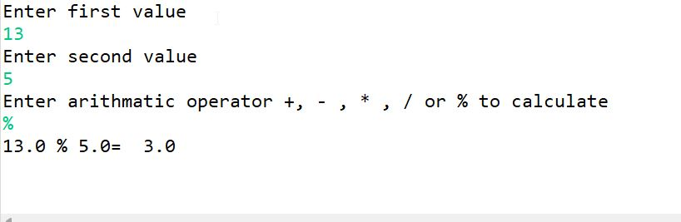

**Multiplication**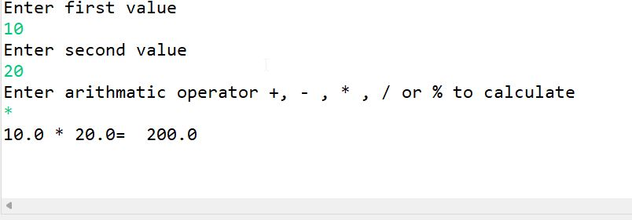

**Division**

